

***EXCELLENT  
COACHINGGGG***

E –project Documentation

Teacher Name: SIR AIJAZ

APTECH COMPUTER EDUCATION

HYDERABAD-1 PAKISTAN



TABLE OF CONTENT

|  |  |  |
| --- | --- | --- |
| **S No** | **Contents** | **Page No** |
| 01 | Certificate | 3 |
| 02 | Acknowledgement | 5 |
| 03 | Project Report | 6 |
| 04 | Problem Definition | 7 |
| 05 | Customer Requirements  Specification  (CRS) | 8 |
| 06 | Architecture Design of the  Project | 10 |
| 07 | System Requirement | 11 |
| 08 | Task Sheet | 12 |
| 09 | Project Plan | 13 |
| 10 | Checklist of work Progress | 14 |
| 11 | Screen Shots | 15 |
| 12 | Source Code | 19 |



CERTIFICATE

This is to certify that

**ALISHA WAJAHAT**

Has successfully Designed

EXECLLENT COACHING

Submitted by:

**ALISHA WAJAHAT**

Issue Date: 16-Mar-2023

**Authorized Signature**: SIR AIJAZ



CERTIFICATE

This is to certify that

**LAIBA AQEEL**

Has successfully Designed

EXECLLENT COACHING

Submitted by:

**LAIBA AQEEL**

Issue Date: 16-Mar-2023

**Authorized Signature**: SIR AIJAZ



**ACKNOWLEDGEMENT**

First and foremost, we would like to express our deep gratitude

And most heartfelt thanks to almighty ALLAH for his blessings,

for lightening up our heart with the torch of knowledge and for

giving us the ability to complete this project.

We would like to thanks Aptech Worldwide and the team of E-

Project for their generous support and clarifying the doubts

regarding e-project. We would like to acknowledge the way of

explanation which the team of e-project gave in e-project to

make website and we are equally grateful to our teacher (Sir

Amjad Ali) for giving us a moral support and guiding us different

matters regarding project in all the time about the research and

writing of this project.

We are greatly indebted to Aptech Worldwide, Sir Amjad Ali,

Faculty Members and ACE Hyderabad, Pakistan for encouragement

and incessant help.

PROJECT REPORT

By:

**Alisha Wajahat**

**Project Title: EXECLLENT COACHING**

**Members Name: LAIBA AQEEL**

**Batch Code: 2210E**

**Start Date: 20-March-2023**

**End Date: 7-April-2023**

**Course: ACCP (CPISM)**

**Teacher: Sir Aijaz**

**Center Manager: Sir Shoaib Ahmed**

**Center Academic Head: Sir Zubair**

**Center Name: ACE Hyderabad-1, Pakistan**



Submitted as

E Project Documentation

**PROBLEM DEFINITION**

Excellent coaching is an educational website with various courses on different subjects available for students.

Also highly qualified teachers have been hired.

Website must be designed for this education showing the collection of knowledge consisting of multiple courses.

Various subjects such as Mathematics, Commerce etc. A website needs to be developing for the education purpose which must display all the collection.

So, taking into consideration the expanding knowledge ,the Excellent Coaching planned to host the primary information via Fun zone.com, an Internet Gateway.

**Customer Requirement Specification**

The Web site is to be created based on the following requirement;

1) The Home Page should have suitable logo, and decent colour combination.

2) Information should be neatly placed at suitable location.

3) Various pages having information about different courses/subjects taught at

the classes, Faculty/Teachers complete information and previous year’s

success stories should be listed.

4) The site should display a menu which will contain the options for brief

introduction about the above mentioned information, location/address of the

coaching classes and any other information if required.

5) The information should be categorized according to different subjects like if a

User wants to see details of ‘Commerce’ then he click on a Link/button/menu

etc and he will see details of course structure of commerce. Similarly for

‘Mathematic’, ‘Languages’ and other subjects.

6) When a user selects any course stream, complete list of subjects for that

course stream will be displayed.

7) Details of the courses should be displayed on the Web Page along with the

title and it should be stored in Individual Word documents which can be

downloaded or viewed by the User who wishes to see the same.

8) Price List for all courses should be available for download.

9) There should be a “Contact Us” page which will have the Address of the

Coaching Classes and the mail address which when



**PROJECT OBJECTIVE:**

The Objective of this program is to give a sample project to work on real life projects. These applications help you build a larger more robust application.

The objective is not to teach you JavaScript/Dreamweaver but to provide you with a real life scenario and help you create basic applications using the tools.

You can revise the chapters before you start with the project.

This project is meant for students who have completed the module of

Dreamweaver. These programs should be done in the Lab sessions with

assistance of the faculty if required.

It is very essential that a student has a clear understanding of the subject. Students should go through the project and solve the assignments as per requirements given.

Kindly get back to Projects Team in case of any doubts regarding the

application or

Its objectives.

Architecture & Design of the

Project:

Since the website will have client server architecture it will have

One-tier architecture.



**System Requirement:**

|  |  |  |
| --- | --- | --- |
| **SR.No** | **Items** | **Description** |
| 01 | Operating  system | Window XP,Win 7 or win 8 |
| 02 | Main Processor | Minimum 2ghz or better |
| 03 | Main (Memory) | Minimum 512mb or better |
| 04 | Web Browser | Google Chrome or Fire Box  (latest) |
| 05 | Software | Notepad ,HTML editor ,  Adobe Dreamweaver CS5.5 |



TASK SHEET

|  |  |  |  |  |  |
| --- | --- | --- | --- | --- | --- |
| Project Ref.No: | | Data of Preparation of Activity Plan: | | | |
| SR.  No | Task | Actual  Start  Date: | Actual Day : | Team  Mates  Names: | Status: |
| 01 | Planning | 17-Mar-2023 | 1 | Laiba Aqeel | Yes |
| 02 | Data  Collection | 19-mar-2023 | 3 | Alisha Wajahat | Yes |
| 03 | Designing  Home  Page | 20-mar-2023 | 4 | Alisha Wajahat | Yes |
| 04 | Linking | 27-Mar-2023 | 9 | Laiba Aqeel | yes |
| 05 | Check Links | 29-Mar-2023 | 2 | Laiba Aqeel | Yes |
| 06 | Finalizing | 5-Apr-2023 | 3 | Alisha Wajahat | Yes |
| 07 | Testing | 6-Apr-2019 | 2 | Sir Aijaz | Yes |
| 08 | Documentation | 18-Mar-2023 | 1 |  | Yes |
| 09 | Uploading | 6-Apr-2019 | 2 | Sir Aijaz | Yes |

**PROJECT PLAN**

• Website is able to execute quickly.

• The color scheme of the site looks attractive.

• The collection of data is authentic and taken by the most

Popular product websites.

• There is authentic information of facilities products with

their specifications.

• Background is different to main page.

• The HOME is well prepared exactly for the same page as

user clicks on the link..

• A visitor can also view the individual image of our every

gallery.



**CHECK LIST OF WORK**

**PROGRESS**

|  |  |  |
| --- | --- | --- |
| **SR.NO** | **Aspect Tested** | **Remarks** |
| 01 | Data Collection | Yes |
| 02 | Designing Home  Page | Yes |
| 05 | Linking the  pages | Yes |
| 06 | Finalization | Yes |
| 08 | Testing The Site | Yes |
| 09 | Documentation | Yes |

**Screenshots**





**About us**



**Courses**

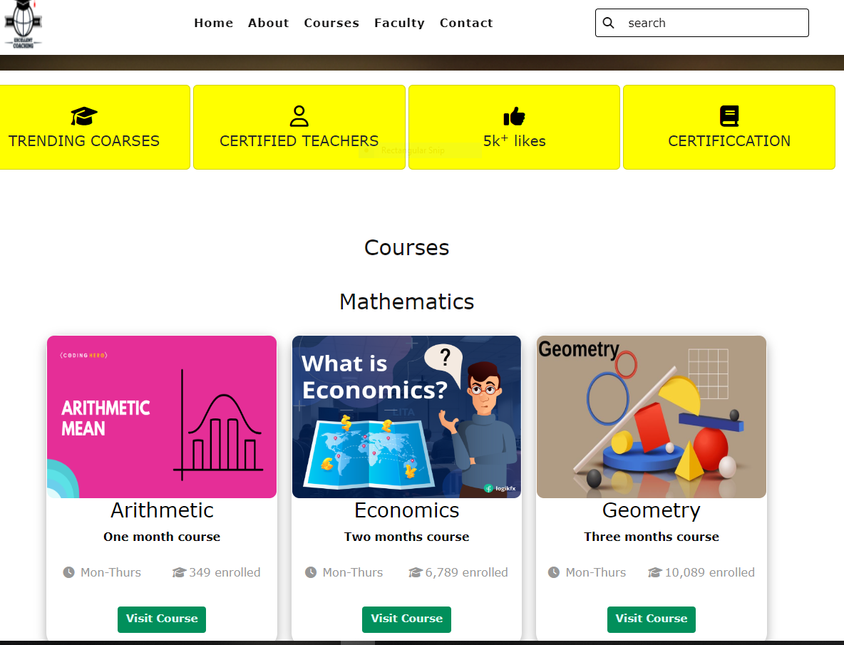

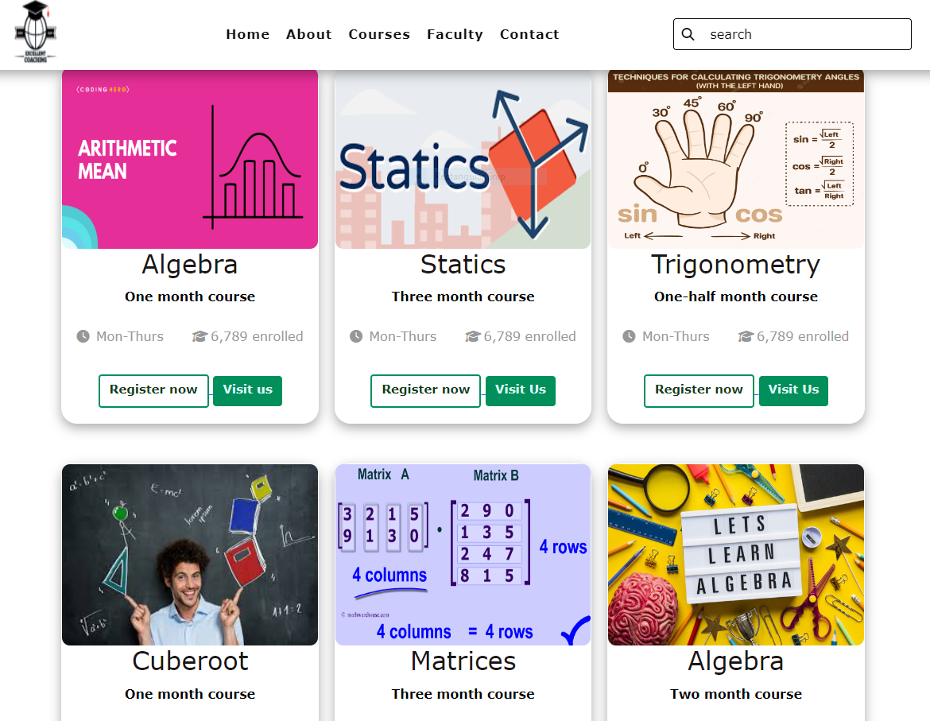

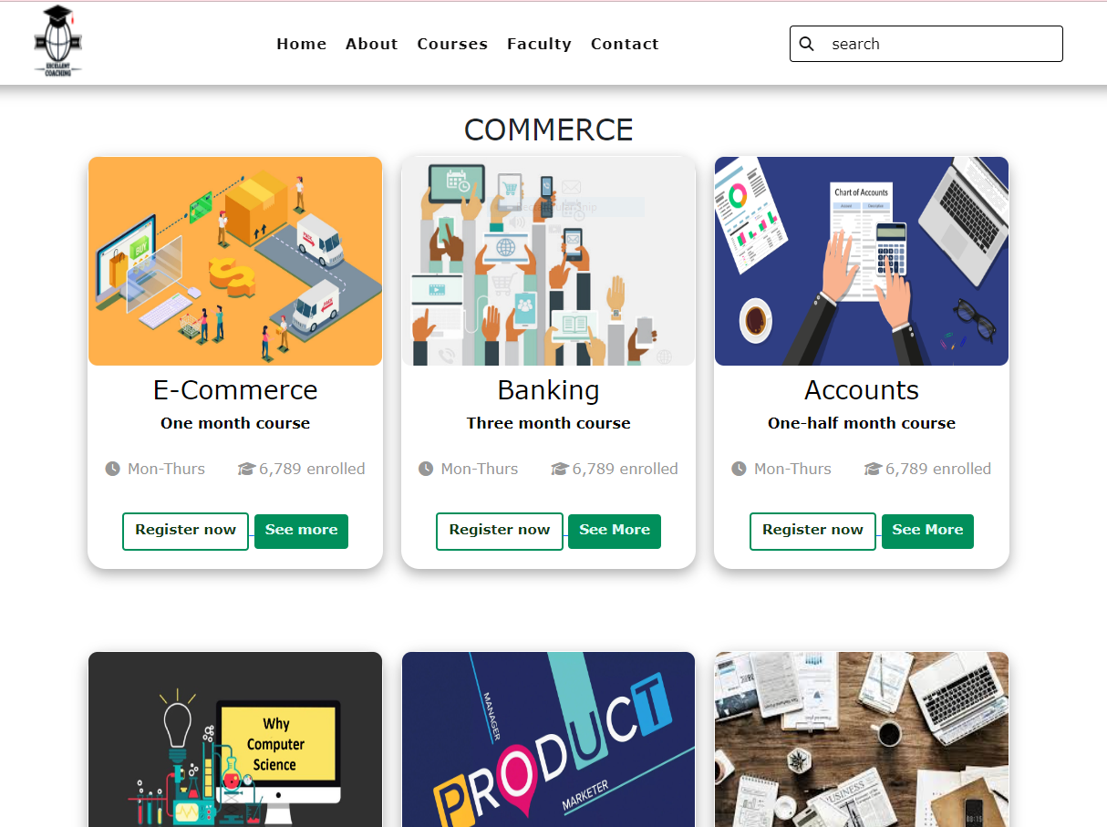

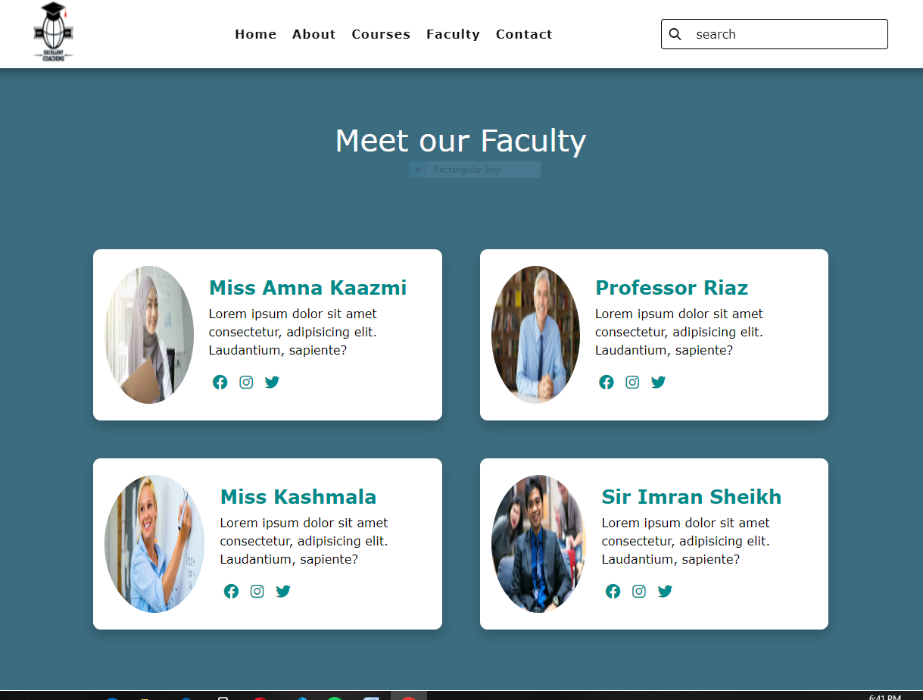

**Contact Us**

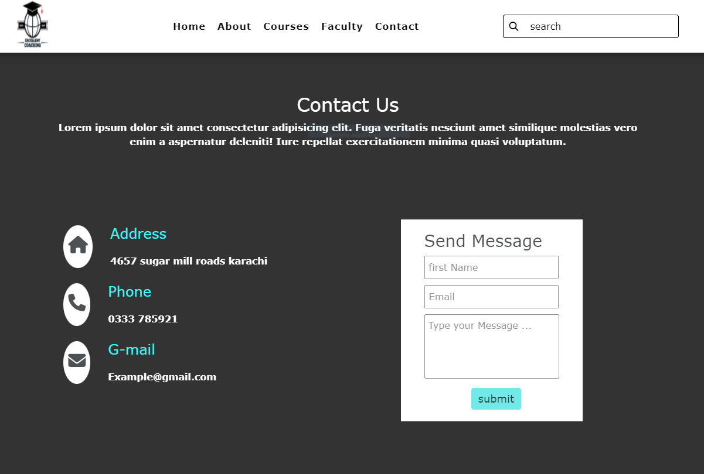



**Description**

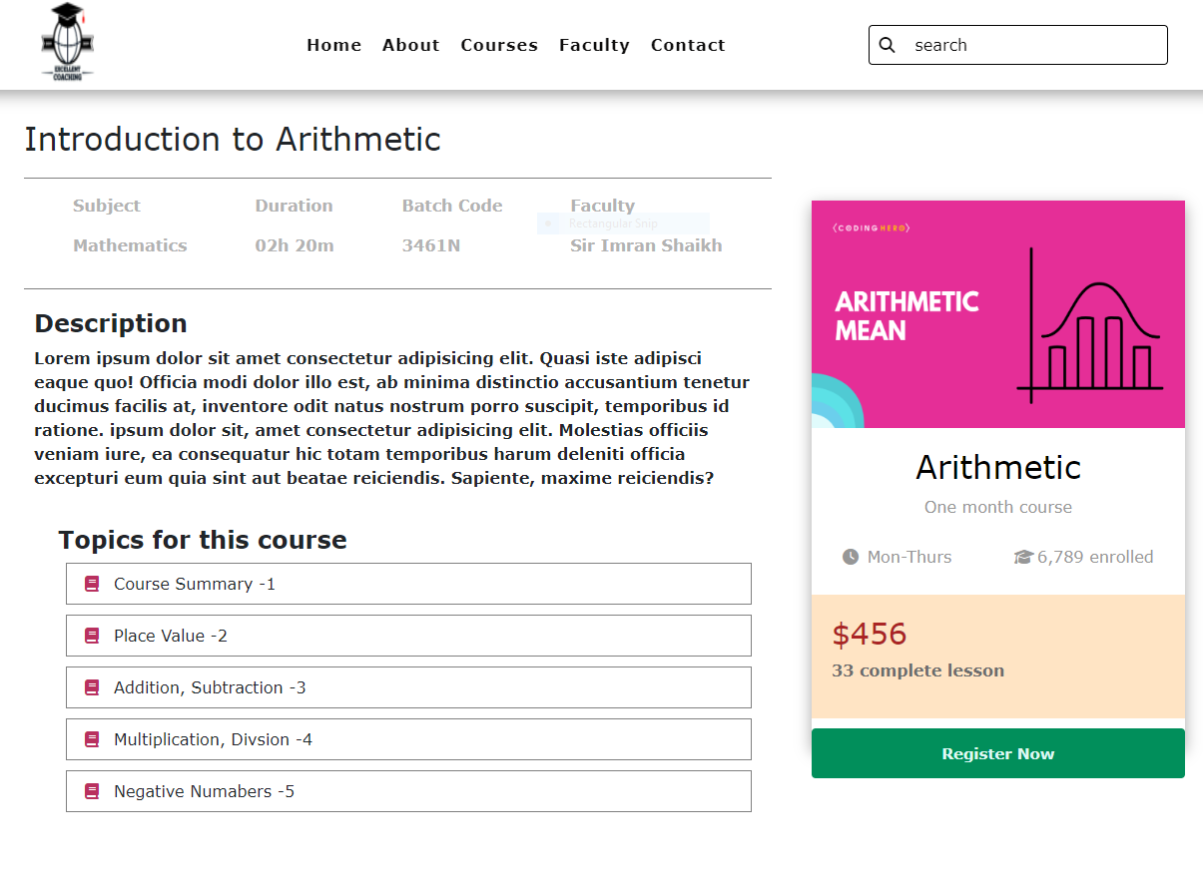

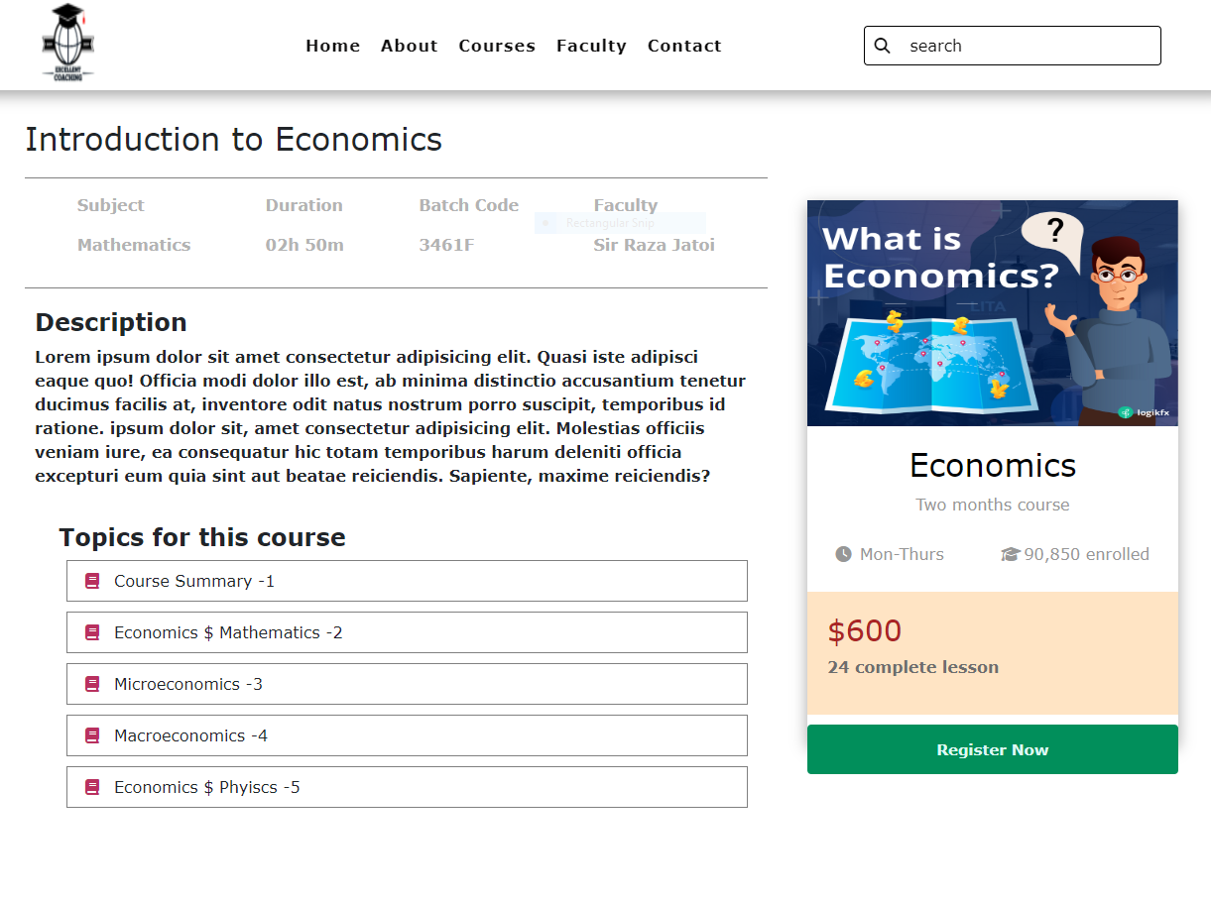

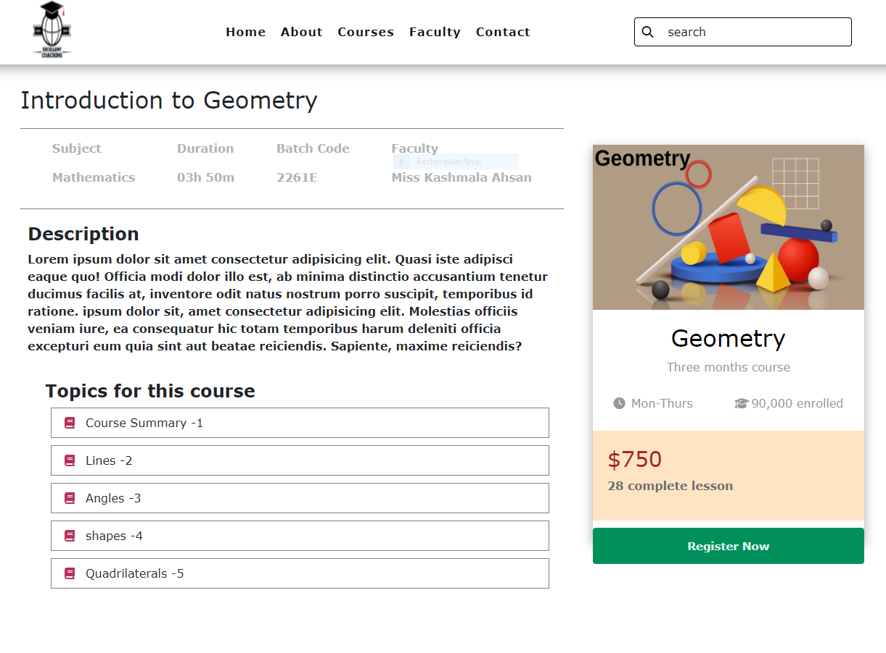

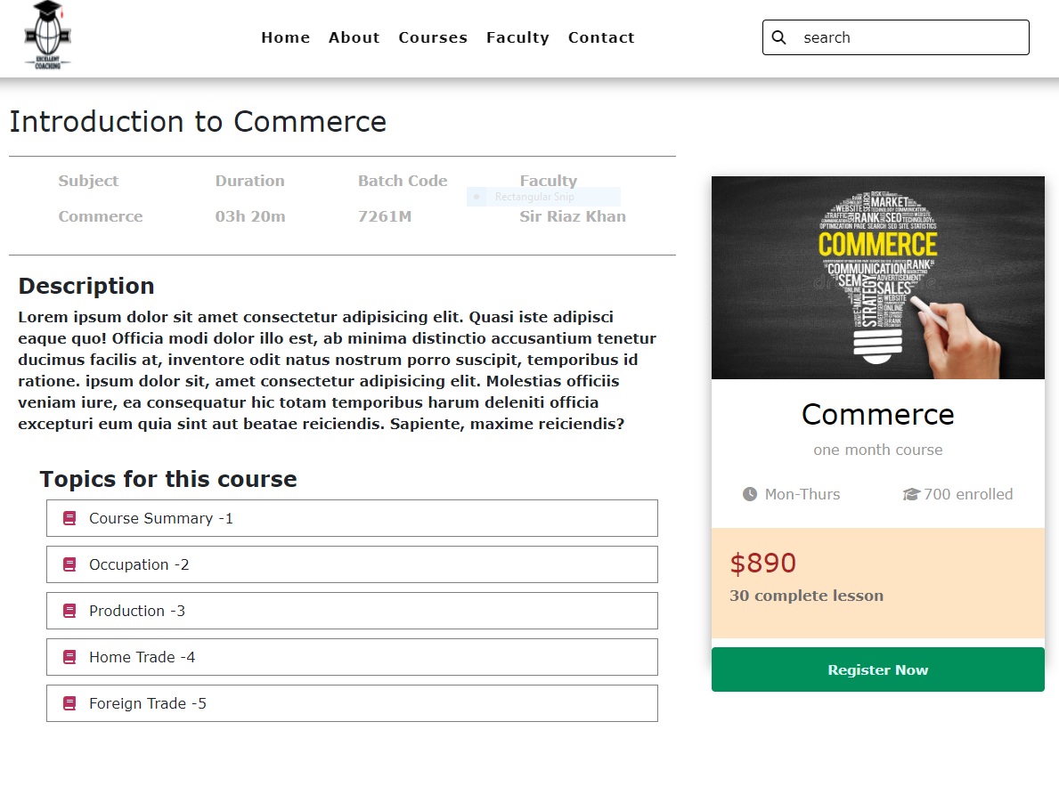

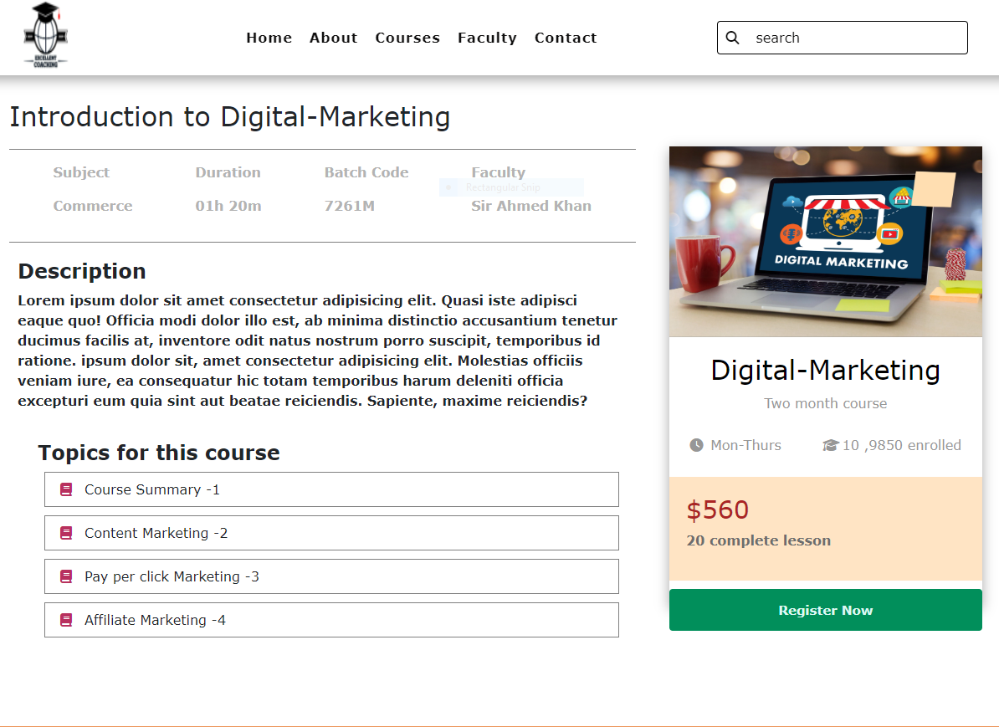

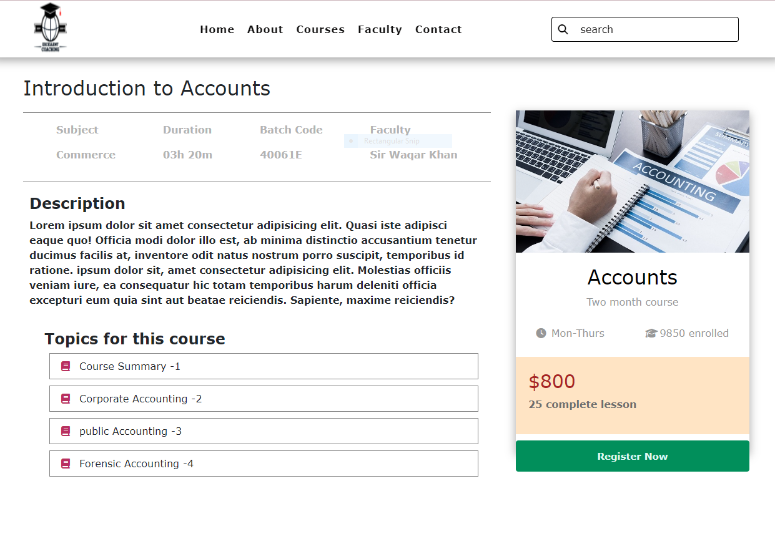

**Registration Form**

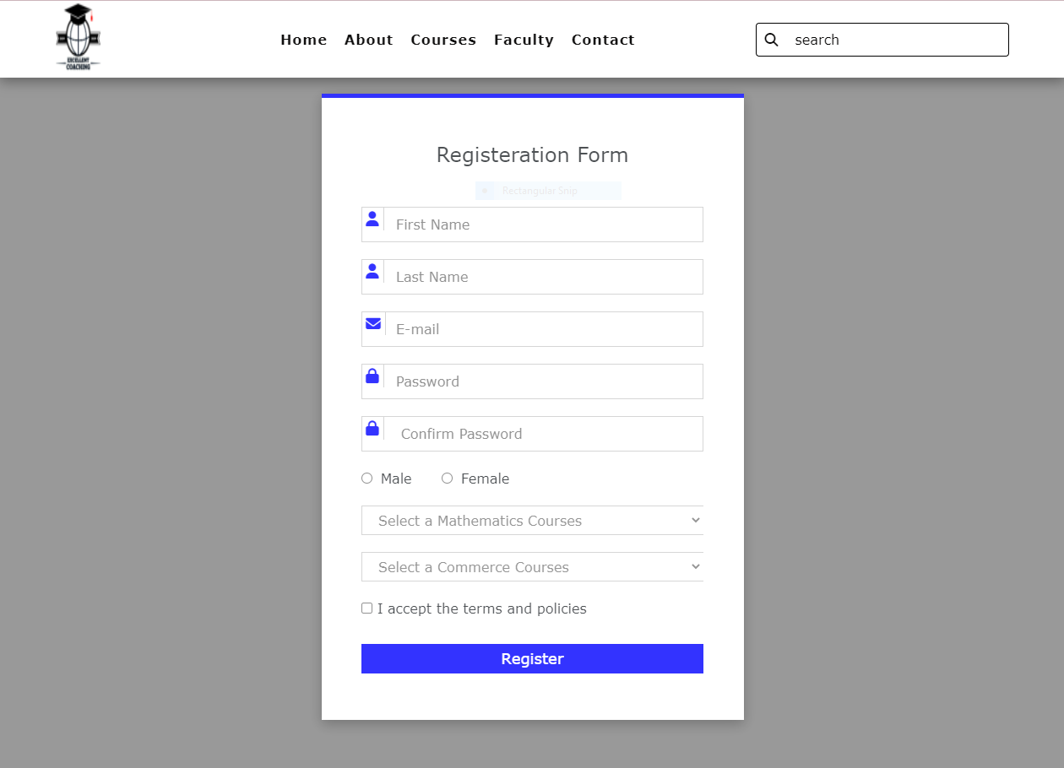

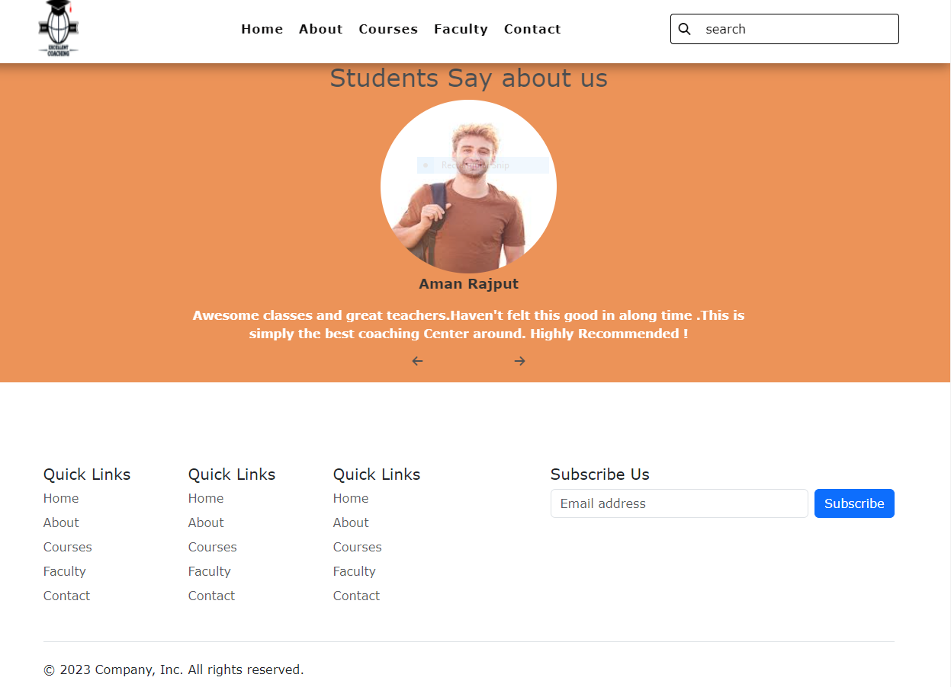



**Source Code**

